Unit 4: EDA - CHIS Exercise

**I. Exploring Data**

# Explore the dataset with summary and str

str(adult)

summary(adult)

# Age histogram

ggplot(adult, aes(x = SRAGE_P)) +

geom_histogram()

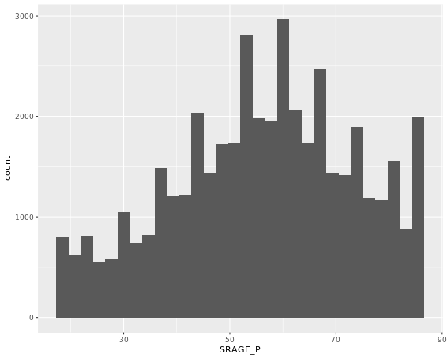

# BMI histogram

ggplot(adult, aes(x = BMI_P)) +

geom_histogram()

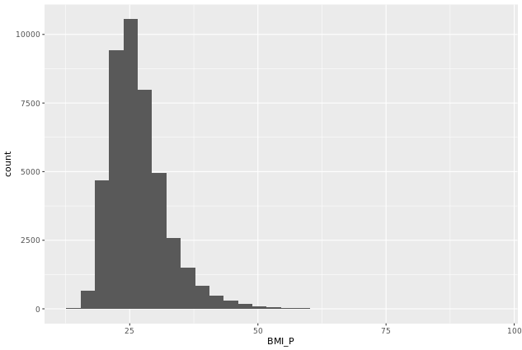

# Age colored by BMI, default binwidth

ggplot(adult, aes(x = SRAGE_P, fill = factor(RBMI))) +

geom_histogram(binwidth = 1)

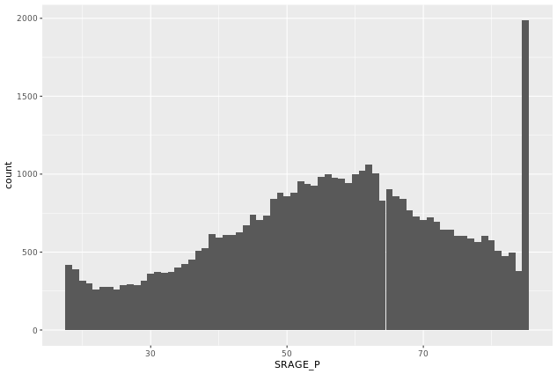

**II. Unusual Values**

One unusual phenomenon that stood out was there was an unexpectedly large number of very old people. It seems everyone 85 and above were categorized as 85 years old.

**III. Default Binwidths**

The binwidth for age variable (SRAGE_P) of the adult dataset is 2.23.

**IV. Data Cleaning**

# Remove individual aboves 84

adult <- adult[adult$SRAGE_P <= 84, ]

# Remove individuals with a BMI below 16 and above or equal to 52

adult <- adult[adult$BMI_P >= 16 & adult$BMI_P < 52, ]

# Relabel the race variable:

adult$RACEHPR2 <- factor(adult$RACEHPR2, labels = c("Latino", "Asian", "African American", "White"))

# Relabel the BMI categories variable:

adult$RBMI <- factor(adult$RBMI, labels = c("Under-weight", "Normal-weight", "Over-weight", "Obese"))

**V. Multiple Histograms**

# The color scale used in the plot

BMI_fill <- scale_fill_brewer("BMI Category", palette = "Reds")

# Theme to fix category display in faceted plot

fix_strips <- theme(strip.text.y = element_text(angle = 0, hjust = 0, vjust = 0.1, size = 14),

strip.background = element_blank(),

legend.position = "none")

# Histogram, add BMI_fill and customizations

ggplot(adult, aes (x = SRAGE_P, fill= factor(RBMI))) +

geom_histogram(binwidth = 1) +

fix_strips +

BMI_fill +

facet_grid(RBMI ~ .) +

theme_classic()

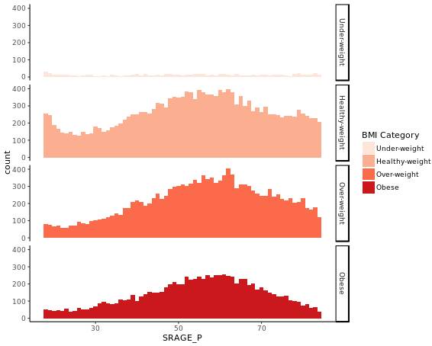

**VI. Alternatives**

# Plot 1 - Count histogram

ggplot(adult, aes (x = SRAGE_P, fill= factor(RBMI))) +

geom_histogram(binwidth = 1) +

BMI_fill

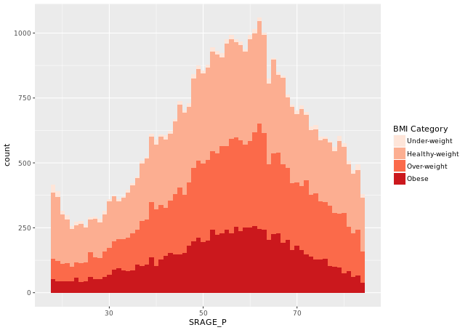

# Plot 2 - Density histogram

ggplot(adult, aes (x = SRAGE_P, fill= factor(RBMI))) +

geom_histogram(aes(y = ..density..),binwidth = 1) +

BMI_fill

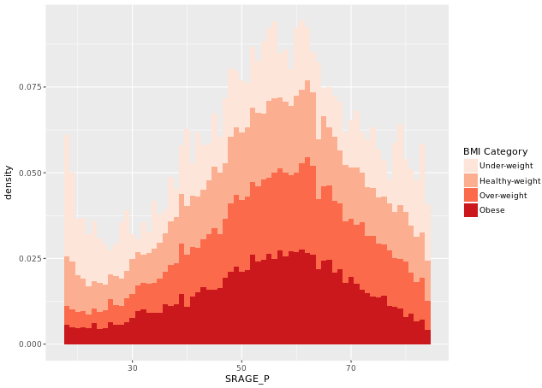

# Plot 3 - Faceted count histogram

ggplot(adult, aes (x = SRAGE_P, fill= factor(RBMI))) +

geom_histogram(aes(y = ..density..),binwidth = 1) +

BMI_fill +

facet_grid(RBMI ~ .)

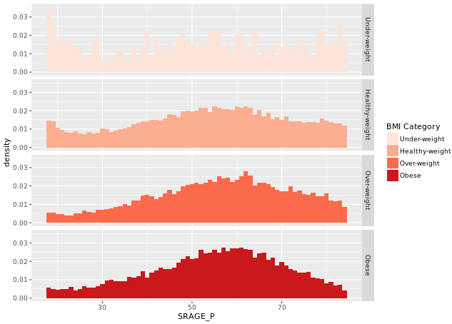

# Plot 4 - Faceted density histogram

ggplot(adult, aes (x = SRAGE_P, fill= factor(RBMI))) +

geom_histogram(aes(y = ..density..),binwidth = 1) +

BMI_fill +

facet_grid(RBMI ~ .)



# Plot 5 - Density histogram with position = "fill" (Across category not bin – not accurate)

ggplot(adult, aes (x = SRAGE_P, fill= factor(RBMI))) +

geom_histogram(aes(y = ..density..),binwidth = 1, position = "fill") +

BMI_fill +

facet_grid(RBMI ~ .)

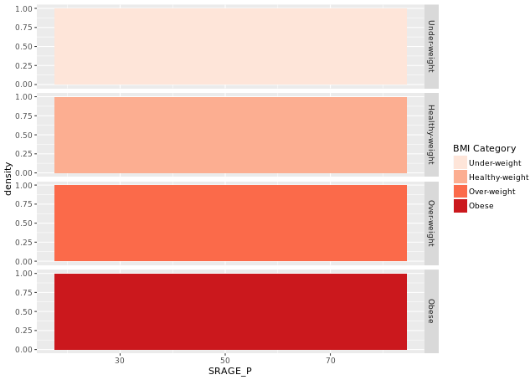

# Plot 6 - The accurate histogram

ggplot(adult, aes (x = SRAGE_P, fill= factor(RBMI))) +

geom_histogram(aes(y = ..count../sum(..count..)),binwidth = 1, position = "fill") +

BMI_fill +

facet_grid(RBMI ~ .)

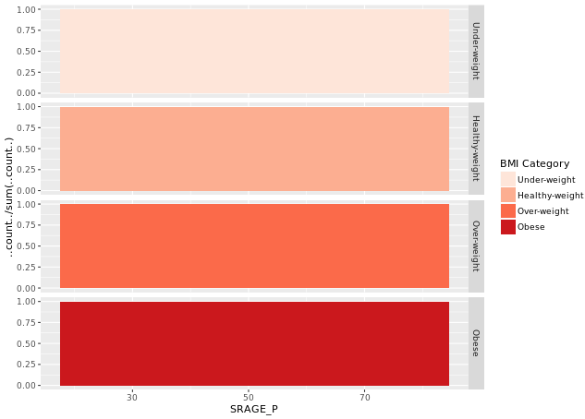

**VII. Do Things Manually**

# An attempt to facet the accurate frequency histogram from before (failed)

ggplot(adult, aes (x = SRAGE_P, fill= factor(RBMI))) +

geom_histogram(aes(y = ..count../sum(..count..)), binwidth = 1, position = "fill") +

BMI_fill +

facet_grid(RBMI ~ .)

# Create DF with table()

DF <- table(adult$RBMI, adult$SRAGE_P)

# Use apply on DF to get frequency of each group

DF_freq <- apply(DF, 2, function(x) x/sum(x))

# Load reshape2 and use melt on DF to create DF_melted

library(reshape2)

DF_melted <- melt(DF_freq)

# Change names of DF_melted

names(DF_melted) <- c("FILL", "X", "value")

# Add code to make this a faceted plot

ggplot(DF_melted, aes(x = X, y = value, fill = FILL)) +

geom_bar(stat = "identity", position = "stack") +

BMI_fill +

facet_grid(FILL ~ .)

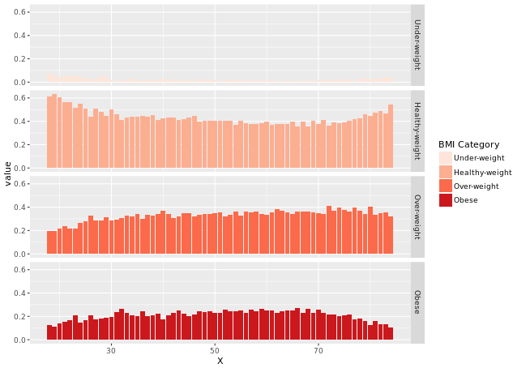

**VIII. Merimeko/Mosaic Plot**

# The initial contingency table

DF <- as.data.frame.matrix(table(adult$SRAGE_P, adult$RBMI))

# Add the columns groupsSum, xmax and xmin. Remove groupSum again.

DF$groupSum <- rowSums(DF)

DF$xmax <- cumsum(DF$groupSum)

DF$xmin <- DF$xmax - DF$groupSum

# The groupSum column needs to be removed, don't remove this line

DF$groupSum <- NULL

# Copy row names to variable X

DF$X <- row.names(DF)

# Melt the dataset

library(reshape2)

DF_melted <- melt(DF, id.vars = c("X", "xmin", "xmax"), variable.name = "FILL")

# dplyr call to calculate ymin and ymax - don't change

library(dplyr)

DF_melted <- DF_melted %>%

group_by(X) %>%

mutate(ymax = cumsum(value/sum(value)),

ymin = ymax - value/sum(value))

# Plot rectangles - don't change.

library(ggthemes)

ggplot(DF_melted, aes(ymin = ymin,

ymax = ymax,

xmin = xmin,

xmax = xmax,

fill = FILL)) +

geom_rect(colour = "white") +

scale_x_continuous(expand = c(0,0)) +

scale_y_continuous(expand = c(0,0)) +

BMI_fill +

theme_tufte()

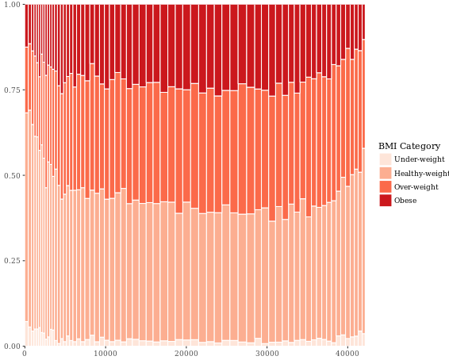

**IX. Adding Statistics**

# Perform chi.sq test (RBMI and SRAGE_P)

results <- chisq.test(table(adult$RBMI, adult$SRAGE_P))

# Melt results$residuals and store as resid

resid <- melt(results$residuals)

# Change names of resid

names(resid) <- c("FILL", "X", "residual")

# merge the two datasets:

DF_all <- merge(DF_melted, resid)

# Update plot command

library(ggthemes)

ggplot(DF_all, aes(ymin = ymin,

ymax = ymax,

xmin = xmin,

xmax = xmax,

fill = residual)) +

geom_rect() +

scale_fill_gradient2() +

scale_x_continuous(expand = c(0,0)) +

scale_y_continuous(expand = c(0,0)) +

theme_tufte()

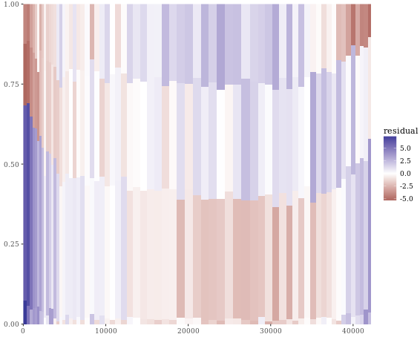

**X. Adding Text**

# Position for labels on x axis

DF_all$xtext <- DF_all$xmin + (DF_all$xmax - DF_all$xmin)/2

# Position for labels on y axis (don't change)

index <- DF_all$xmax == max(DF_all$xmax)

DF_all$ytext <- DF_all$ymin[index] + (DF_all$ymax[index] - DF_all$ymin[index])/2

# Plot

ggplot(DF_all, aes(ymin = ymin, ymax = ymax, xmin = xmin,

xmax = xmax, fill = residual)) +

geom_rect(col = "white") +

# geom_text for ages (i.e. the x axis)

geom_text(aes(x = xtext,

label = X),

y = 1,

size = 3,

angle = 90,

hjust = 1,

show.legend = FALSE) +

# geom_text for BMI (i.e. the fill axis)

geom_text(aes(x = max(xmax),

y = ytext,

label = FILL),

size = 3,

hjust = 1,

show.legend = FALSE) +

scale_fill_gradient2() +

theme_tufte() +

theme(legend.position = "bottom")

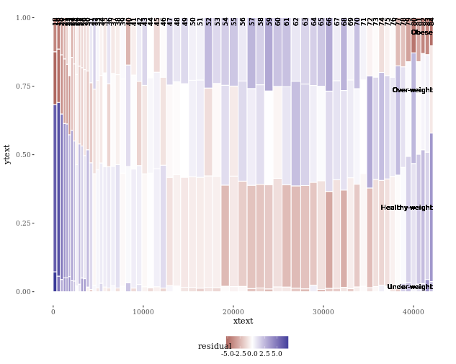

**XI. Generalization**

# Load all packages

library(ggplot2)

library(reshape2)

library(dplyr)

library(ggthemes)

# Script generalized into a function

mosaicGG <- function(data, X, FILL) {

# Proportions in raw data

DF <- as.data.frame.matrix(table(data[[X]], data[[FILL]]))

DF$groupSum <- rowSums(DF)

DF$xmax <- cumsum(DF$groupSum)

DF$xmin <- DF$xmax - DF$groupSum

DF$X <- row.names(DF)

DF$groupSum <- NULL

DF_melted <- melt(DF, id = c("X", "xmin", "xmax"), variable.name = "FILL")

library(dplyr)

DF_melted <- DF_melted %>%

group_by(X) %>%

mutate(ymax = cumsum(value/sum(value)),

ymin = ymax - value/sum(value))

# Chi-sq test

results <- chisq.test(table(data[[FILL]], data[[X]])) # fill and then x

resid <- melt(results$residuals)

names(resid) <- c("FILL", "X", "residual")

# Merge data

DF_all <- merge(DF_melted, resid)

# Positions for labels

DF_all$xtext <- DF_all$xmin + (DF_all$xmax - DF_all$xmin)/2

index <- DF_all$xmax == max(DF_all$xmax)

DF_all$ytext <- DF_all$ymin[index] + (DF_all$ymax[index] - DF_all$ymin[index])/2

# plot:

g <- ggplot(DF_all, aes(ymin = ymin, ymax = ymax, xmin = xmin,

xmax = xmax, fill = residual)) +

geom_rect(col = "white") +

geom_text(aes(x = xtext, label = X),

y = 1, size = 3, angle = 90, hjust = 1, show.legend = FALSE) +

geom_text(aes(x = max(xmax), y = ytext, label = FILL),

size = 3, hjust = 1, show.legend = FALSE) +

scale_fill_gradient2("Residuals") +

scale_x_continuous("Individuals", expand = c(0,0)) +

scale_y_continuous("Proportion", expand = c(0,0)) +

theme_tufte() +

theme(legend.position = "bottom")

print(g)

}

# BMI described by age

mosaicGG(adult, "SRAGE_P", "RBMI")

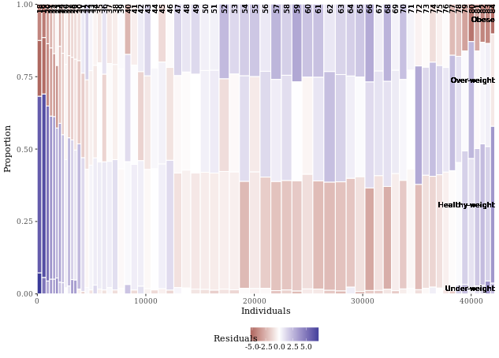

# Poverty described by age

mosaicGG(adult, "SRAGE_P", "POVLL")

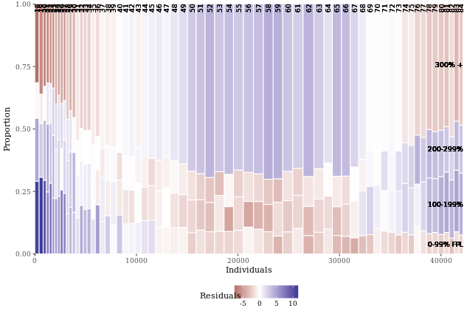

# mtcars: am described by cyl

mosaicGG(mtcars, "cyl", "am")

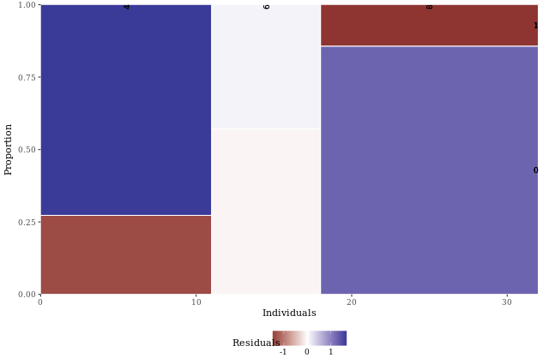

# Vocab: vocabulary described by education

library(car)

mosaicGG(Vocab, "education", "vocabulary")

